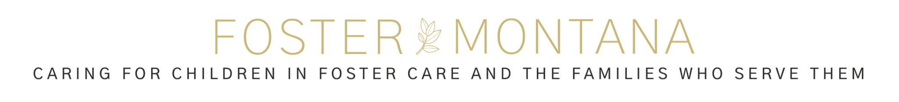

To our Local Churches and Business Owners,

I wanted to introduce myself and the new 501(c3) organization that I am in the process of bringing to Whitehall and Butte.

Foster Montana is a DBA under Partners United for Life Saving Education (PULSE). PULSE has graciously allowed me to form Foster Montana as a DBA under their non-profit organization. In addition to that they assist with bookkeeping and other manpower.

My name is Kamrie Smith. I have been an EMT in Whitehall for almost 10 years, and my husband, Brandon, is a life-long Whitehall resident and rancher. Our three forever kids range in age from 2yo-5yo, and we have had 20 foster children through our home over the course of the past 6 years (mostly short-term and respite).

I have a passion for caring for the kids in foster care and the families who step in to care for them. Oftentimes, a child being placed into foster care is removed from their home swiftly and leaves their personal belongings behind. Putting the responsibility of replacing those items on the foster family who will not receive financial support for quite some time.

I have been this parent, freshly saying “yes” to a child or sibling group and not knowing where to start on collecting items for them with very little time to prepare. It can be overwhelming! You desperately want these children to feel welcomed and thought-about when they arrive. Sometimes with 2 hours notice, sometimes with 2 days notice.

Foster Montana aims to bring very practical support to children entering foster care and their families. We have a mission to provide luggage filled with size appropriate new clothing, comfort items, personal hygiene products, car seats, diapers, and anything else the foster family may request in order to be better equipped to say “Yes!” to a child. These items, along with a meal, will be dropped off at the door of the foster home within hours of them accepting a new placement. This will allow the foster family to focus on the most important thing; making that child feel comfortable in their new home.

We want kids experiencing the trauma of foster care to feel seen, heard, and loved. We want the foster families to feel support from their community. In order to do this, we are seeking tax-deductible donations of new childrens items of all kinds, as well as monetary donations that can be made through our website or by sending a check to PULSE PO BOX 511 Whitehall, MT 59759 (be sure to put ‘Foster Montana’ in the memo!). We are also seeking volunteers who would be willing to sacrifice any amount of time, big or small, to tasks like shopping for specific items as needed (with Foster Montana funds), organizing donations in the storage room, applying for grants on our behalf, delivering items to doorsteps, or other tasks that you feel gifted at.

Please check out our website for more information at: <https://fostermontana.godaddysites.com/>

Thank you for your consideration of supporting our non-profit and making a difference for children and families in our community!

Kamrie Smith

PULSE DBA Foster Montana (EIN# 47-1606772)

406-880-3003

[kamrie.smith@jvemsr.org](mailto:kamrie.smith@jvemsr.org)